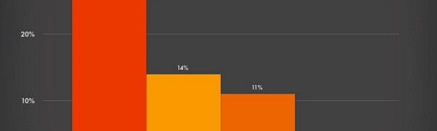
Career Portfolio
Upon the completion of my Bachelor of Arts in Education (counseling psychology) degree, I will seek a position as a corrections counselor. This position will provide many career opportuniti…
Go to this Sway

